**Project Document: SQL**

**Date:** 24th July 2025

**1. Introduction:**

This project is about understanding the basics and use-cases of SQL in the real business scenarios. Concepts like DDL, DML, DQL are understood by this project.

This project also gives a hands-on experience on the automation and testing part of the SQL.

**2. Project Goal and Objectives:**

There are 10 tasks which are to be completed to have a holistic view about the understanding of SQL and learn business cases where it is used.

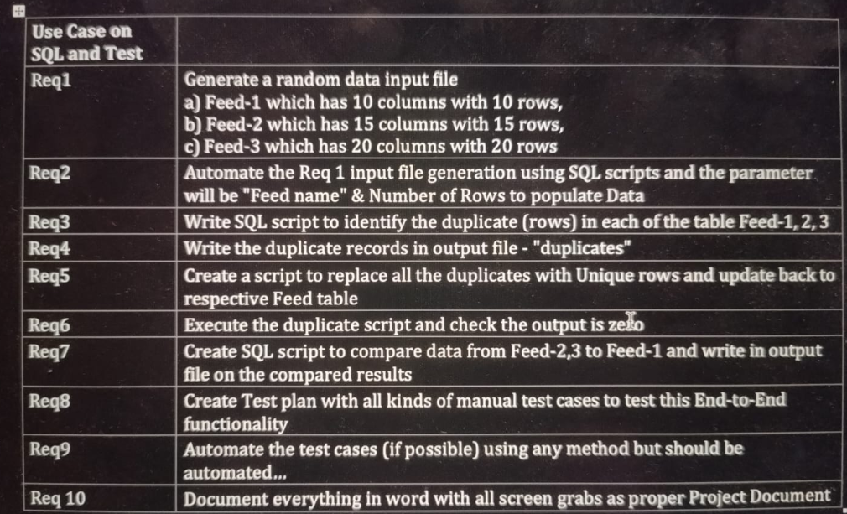

**3. Requirements :**

**PostgreSQL (v17), PgAdmin and Terminal**

**4. Resources:**

* Udemy
* Youtube
* W3 School
* GeeksforGeeks

**Screen Grabs**

**Requirement 1:**

* **Table Feed_1 with 10 rows and 10 columns**

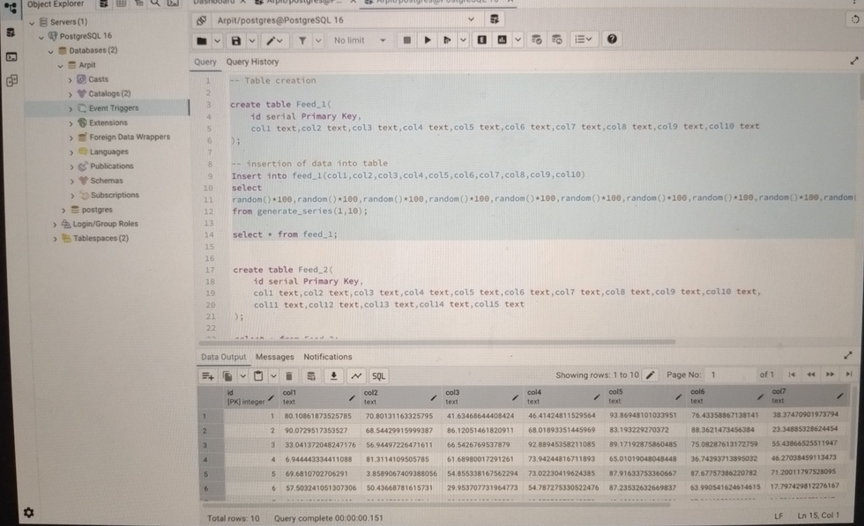

* **Table Feed_2 with 15 rows and 15 columns**

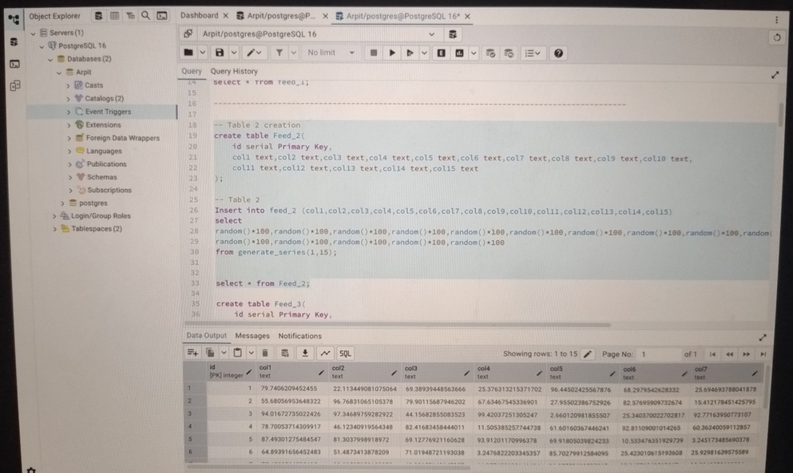

* **Table Feed_3 with 20 rows and 20 columns**

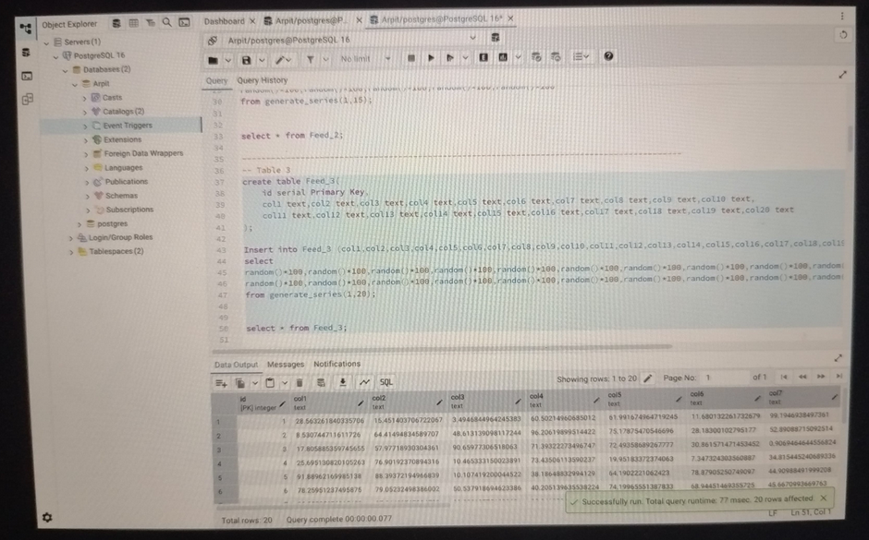

**Requirement 2:**

* **Automatic table creation and calling it with parameters as Feed name and no. of row.**

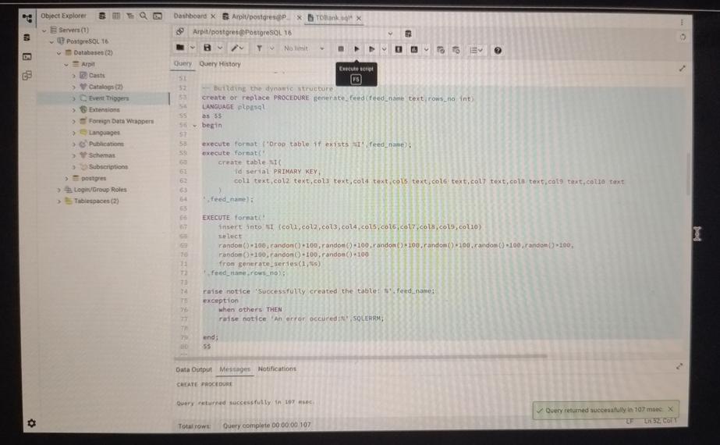

* **Creation of Feed_5 with 10 rows**

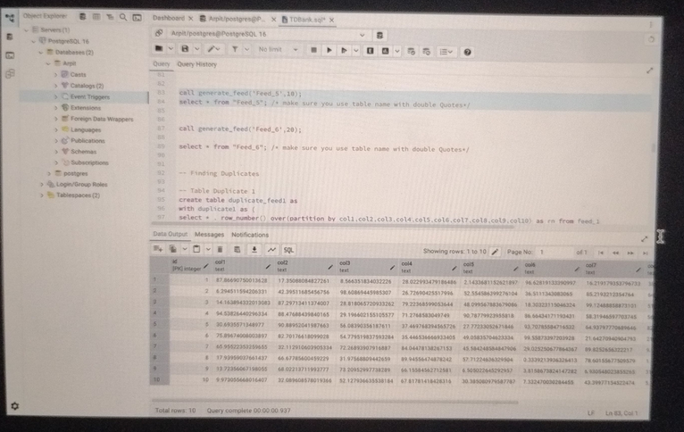

* **Creation of Feed_6 with 20 rows**

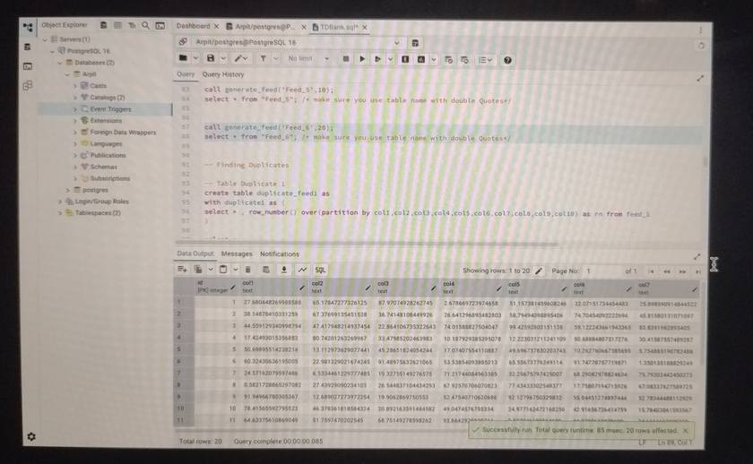

**Requirement 3:**

* **Adding 2 similar values in Feed_1**

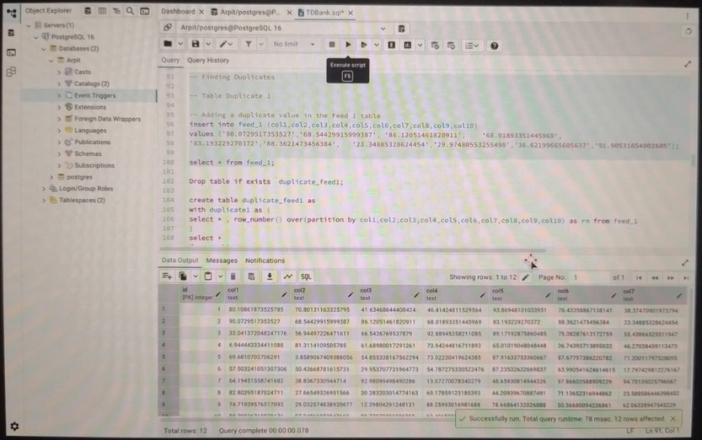

* **Searching for duplicates in Feed_1**

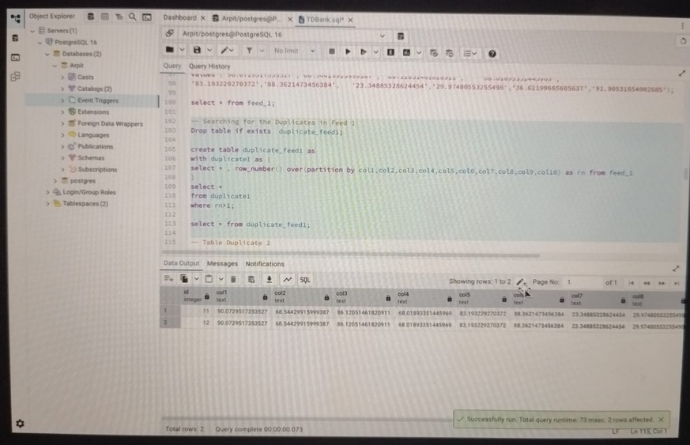

* **Adding 2 similar values in Feed_2**

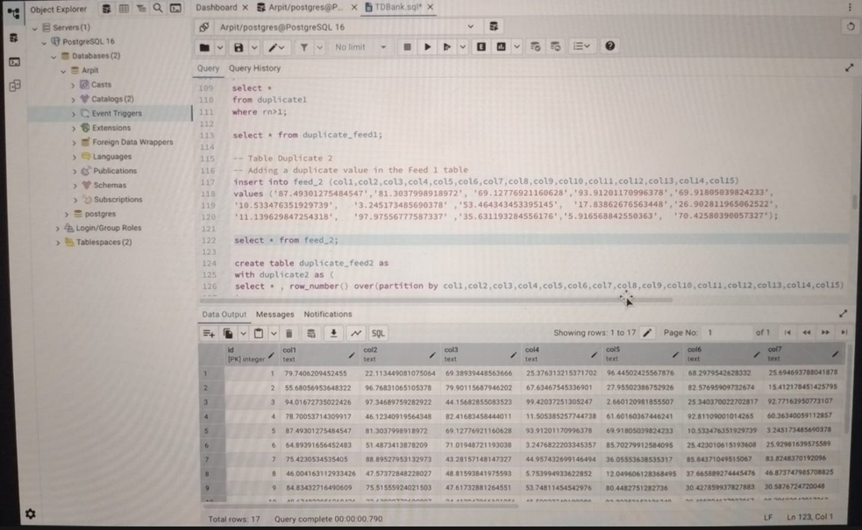

* **Searching for duplicates in Feed_2**

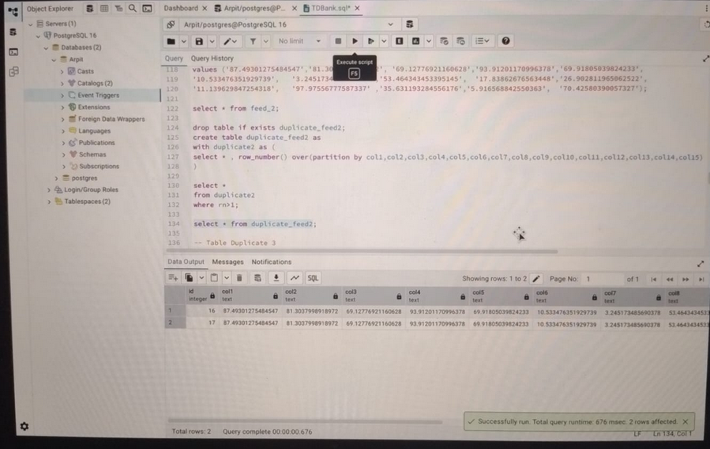

**Adding and searching for similar values in Feed_3**

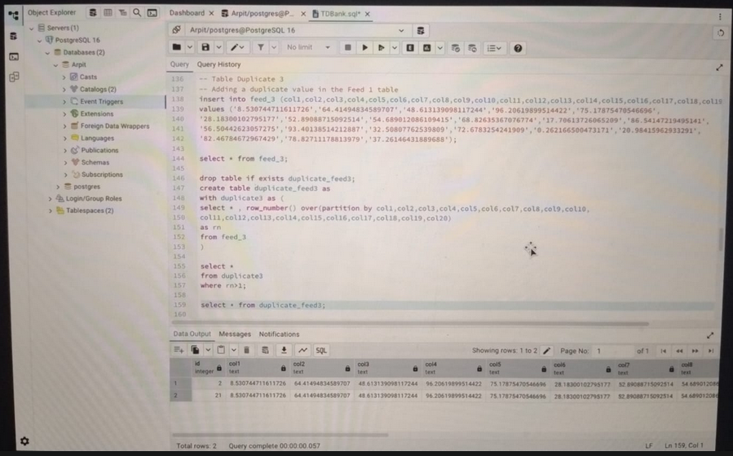

**Requirement 4:**

* **Did this with GUI of PostgreSQL as CMD requires some permissions which Wipro’s laptop was not giving.**

**Requirement 5:**

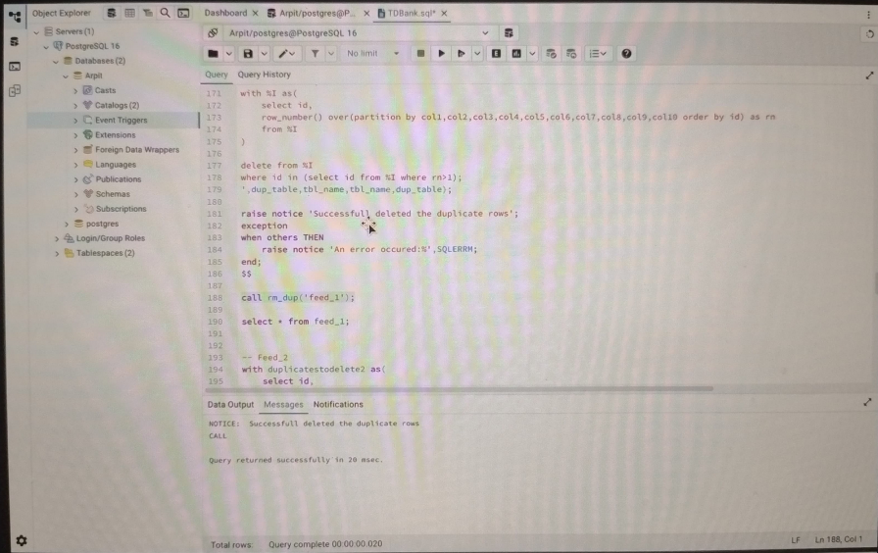

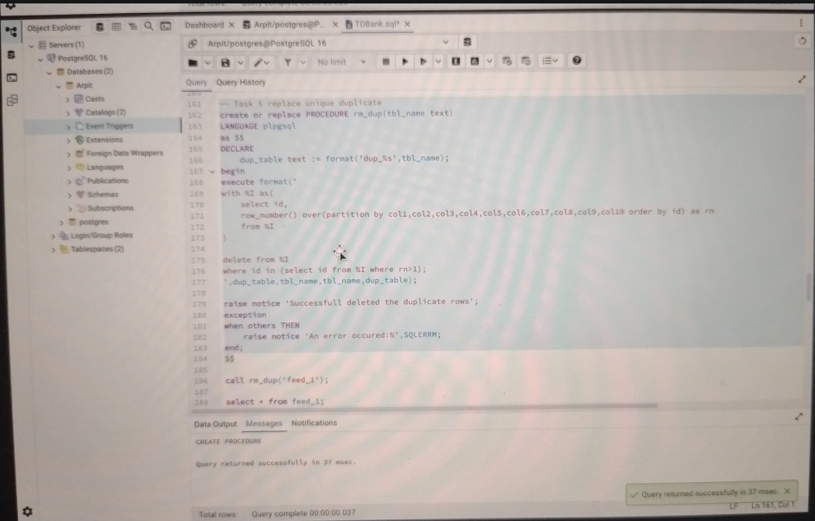

**Requirement 6:**

**Requirement 7:**

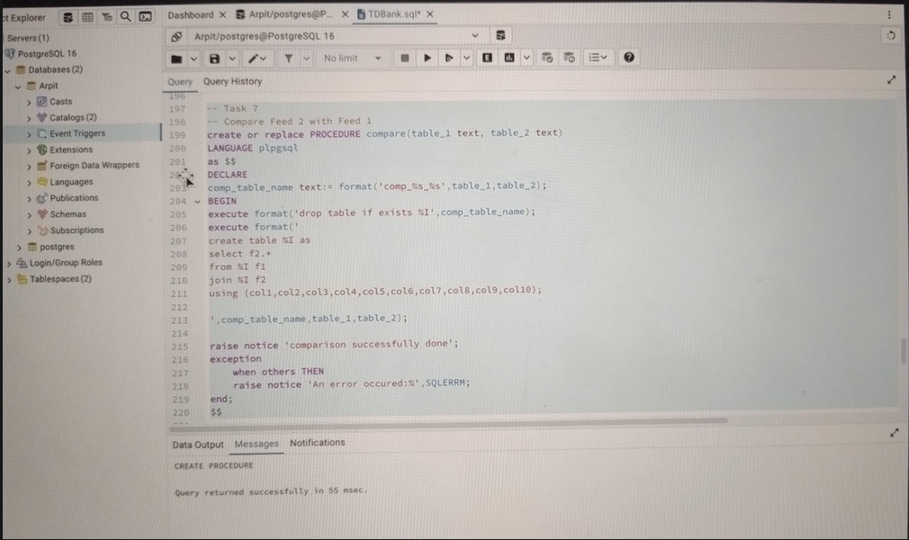

**Checking the status of query**

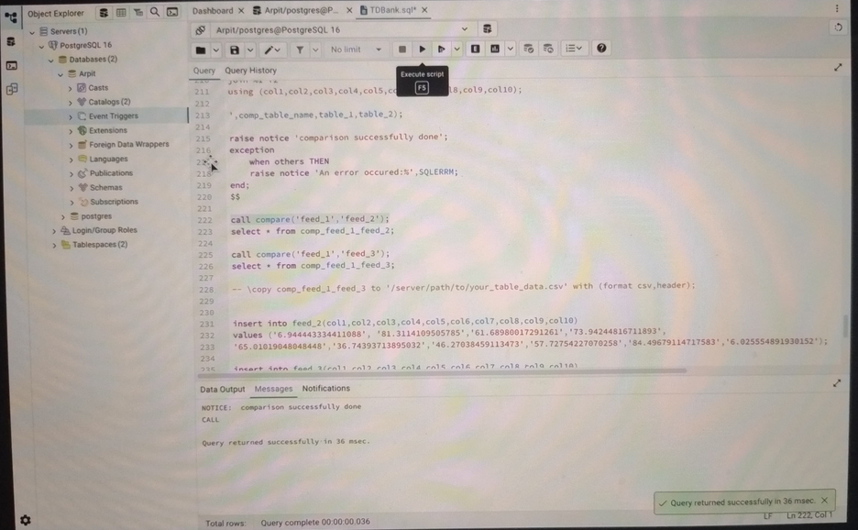

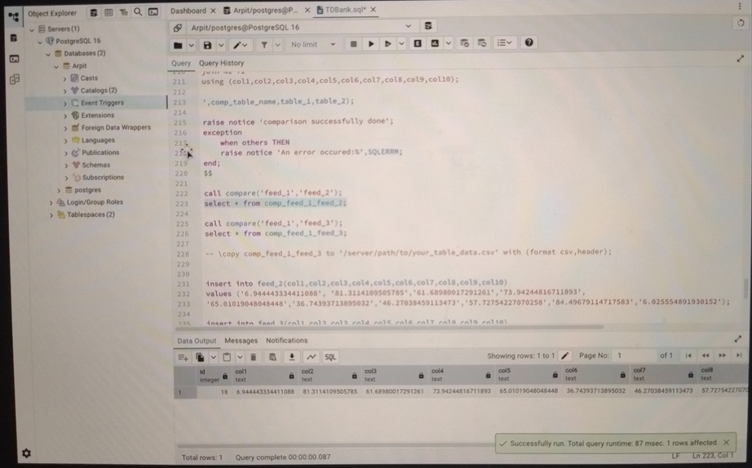

**Requirement 8:**

**Test objectives:**

**1. Verify correct generation of data feeds with specified dimensions.**

**2. Confirm accurate generation and reporting of duplicate records.**

**3. Ensure success removal of duplicate records, leaving only one unique entry.**

**4. Validate comparison logic between different data feeds.**

**Requirement 9:**

**Automation done in some Requirements using Stored Procedures.**